SECTION DA

PRIMING, VENTING, INITIAL STARTING  
PREPARATIONS, STARTING AND STOPPING

CONTENTS

Chapter

Initial Starting Preparations (including Priming and Venting) .. .. 1

Check List for Initial Start .. .. .. .. .. .. .. 2

Engine Starting and Stopping .. .. .. .. .. .. 3

Protection Features .. .. .. .. .. .. .. .. 4

Engine Barring Equipment .. .. .. .. .. .. .. 5

INITIAL STARTING PREPARATIONS

(Including Priming and Venting)

GENERAL

1. Before starting the engine, the operator should make himself thoroughly familiar with the various controls, piping arrangements, and the location and function of all protection switches and devices fitted.
2. The following instructions should be observed at each of the undermentioned occasions:
3. After installation.
4. Following a major overhaul.
5. If the lubrication, fuel or cooling systems have been disturbed.

CAUTION BEFORE COMMENCING ANY WORK ON AN ENGINE OR

GEARBOX, CARRY OUT ONE OF THE FOLLOWING:

1. TO ISOLATE THE THE STARTER MOTORS FROM THE START CIRCUIT TURN THE D.C. ISOLATOR ON THE PROPULSION LOGIC CONTROL PANEL TO OFF, THIS WILL ISOLATE THE START BUTTONS BUT WILL NOT ELECTRICALLY ISOLATE THE STARTER MOTORS.
2. TO ELECTRICALLY ISOLATE THE STARTER MOTORS FROM THE SHIPS SUPPLY REMOVE THE COVER FROM THE STARTER RELAY PANEL ON ’A’ BANK SIDE OF THE ENGINE AND REMOVE THE LINK IN FITTED IN THE BATTERY NEGATIVE LEAD.

COOLING SYSTEM

1. Open all the isolating valves on the coolant make-up tank and the two valves in the pre-warming circuit.
2. Fill the engine cooling system with clean, treated water (see Section KA). The engine system is self venting but time must be allowed for air to be expelled.
3. Examine the system for leaks and rectify where necessary.
4. Prime the sea water pump (Section KC).

LUBRICATION SYSTEM

1. Fill the engine lubricating oil sump to the 'MAX STATIC' mark on the dipstick with clean, new lubricating oil of the correct grade (see Appendix A).
2. Check that the 'Prime/Sump Drain' changeover cock is in the 'Prime' position.
3. Open the air vent on the main lubricating oil filter. Operate the semi-rotary hand priming pump to fill the lubricating oil piping and filter. Close the air vent immediately air-free oil commences to flow from the filter.
4. Remove all valve covers and crankcase doors and fit a temporary pipe between the fuel pump cambox oil drain bosses and the crankcase. Operate the hand priming pump and check that oil is draining from the main and large-end bearings, from the small-end bearings and piston spray, indicated by a small flow down the bore of the liner, and is reaching the valve rocker gear. It is advantageous to bar the crankshaft through two complete revolutions during this operation. Replace the doors and covers in their original positions to minimise the possibility of oil leakage.
5. Remove the blanking covers from the underside of both fuel injection pump camboxes and place suitable receptacles beneath each aperture to collect the lubricating oil. Operate the hand priming pump and check that oil is draining from all bearings of both camshafts. Replace the covers in their original positions to minimise the possibility of oil leakage. (This operation need only be carried out if the engine has not been run after overhaul prior to installation in vessel).
6. Release the oil supply pipe at the inlet to the overspeed trip unit, operate the hand priming pump and check that oil is reaching the unit. Re-connect the piping. This check also verifies the oil supply to the turbocharger.
7. Release the drive-end connections on the lubricating oil pipes supply 'A' and 'B' bank fuel injection pumps and operate the hand priming pump to expel all air from the pipes. Tighten connections.
8. Allow approximately 15 minutes for excess oil to drain back to the sump, check the oil level and top up to the 'MAX STATIC' mark on the dipstick.
9. Fill the engine governor with clean, new engine oil to the level marked on the sight- glass (see Section HA). DO NOT OVERFILL.
10. Apply grease gun containing SHELL LIVONA GREASE 3, or equivalent, to the nipple of sea water pump drive jockey pulley and lubricate the spindle bearings. DO NOT over grease (see Section KC).
11. Fill the gearbox to the upper mark on the dipstick with clean, new oil of the recommended grade (see Section P).

FUEL SYSTEM

1. The object of priming and venting is to ensure that the system is completely filled with fuel and all air expelled. Difficult starting and imperfect injection may be due to incorrect venting.
2. Fill the fuel tank with water free fuel of the correct specification (see Section GA). Open the fuel supply valve between the fuel tank and engine. Open the fuel bypass valve across the fuel feed pump, and operate the manual fuel oil priming pump to provide a flow of fuel to the engine to prime the system.
3. Release the vent plug on the chip filter. When air-free fuel commences to flow, close the vent plug.
4. From this point onwards the fuel system is self venting, fuel flowing to the first stage of the fuel reservoir, the lower fuel galleries, fuel injection pumps, upper fuel galleries and back to the second stage of the fuel reservoir. All air displaced is passed to the fuel reservoir second stage from where it is returned to the fuel tank via a permanent bleed.
5. Completion of priming may be determined by slackening off the fuel return connection at the reservoir head casting and checking for fuel. Re-tighten connection.
6. Close the bypass valve across the fuel feed pump.

AIR INTAKE FILTERS

1. Prepare the air intake filter elements as detailed in Section LA.

ENGINE STARTING BATTERIES

1. Ensure that the starting batteries are fully charged.

TURNING THE ENGINE

1. Rotate the engine in the direction of rotation through two revolutions, with the barring tool, to ensure that all working parts are free. REMOVE THE BARRING TOOL IMMEDIATELY AFTER USE.

CHECK LIST - INITIAL START

NOTE A pre-warming unit for the engine coolant is fitted to each engine (refer to Section KA). The purpose of this unit is to maintain the engine coolant at a preset temperature during engine shutdown, thus eliminating the need for a warming-up period and enabling the engine to be placed on load immediately after starting.

FIRST RUN, NO LOAD

1. Carry out the following pre-start checks:-
2. Coolant level in make-up tank
3. Fuel level in daily service tank
4. Lubricating oil levels in engine sump, governor and gearbox.
5. Overspeed trip governor reset button is depressed
6. Air shutdown release valve units are latched open
7. Start each engine as detailed in Chapter 3. It will be necessary to assist engine control by hand until the governor has vented itself of all air and assumes full control.
8. Check that idling speed is correct.
9. Remove the valve gear covers and check that a satisfactory supply of oil is reaching the valve rocker gear. Due to oil splash from the rocker gear, covers should be removed for as brief a period as possible.
10. Stop the engine. Allow approximately 15 minutes for excess oil to drain back to the sump and check the oil level. Top up to the 'MAX STATIC' mark on the dipstick.
11. Top up the oil level in the engine governor to the mark on the sight glass. The level will have fallen due to the filling of the starting oil accumulator.

FIRST RUN ON LOAD

1. Start the engine as detailed in Chapter 3. If the pre-warming units have not been in operation, allow the engine to warm through for approximately 5 minutes.
2. Engage the gearbox to place the engine on load.
3. Operate the engine until temperatures and pressures stabilise and check oil, fuel and

coolant temperatures and/or pressures of engine and gearbox against figures quoted in Section C (engine) and Section P (gearbox).

1. Check exhaust temperatures against figures in the Engine Test Sheets.

OPERATIONS NECESSARY AFTER FIRST RUN ON LOAD

1. Check all tappet clearances and adjust if necessary (see Section FA).
2. Check oil levels in engine sump, governor and gearbox. Top up to correct level, if

necessary.

1. Check complete installation for oil, fuel and coolant leaks.
2. Check all external nuts, bolts, setscrews, clips, etc, for tightness and security.

LIMITED RIGHTS LEGEND

6

USE, DUPLICATION OR DISCLOSURE OF THIS INFORMATION WHICH IS THE PROPERTY

OF GEC ALSTHOM DIESELS LIMITED BY THE U.S. GOVERNMENT OR BOLLINGER IS SUBJECT TO THE RESTRICTIONS SET FORTH IN I)OD FAR SUPP 252.227-7013 (a) 15.

ENGINE STARTING AND STOPPING

1. Start/Stop buttons are provided to enable the engines to be started and stopped individually at the following control positions:-
2. Engineer Operating Station - E.O.S
3. Pilot House Drop In Plate - P.H
4. Bridge Wing Drop In Plates Port and Starboard - B.W
   1. Engine may be started from any one of the control positions PROVIDED THAT THE CONTROL TRANSFER SWITCHES ARE SET FOR THAT POSITION.
   2. When starting from 'COLD', particularly in harbour, STARTING MUST BE CARRIED OUT FROM THE ENGINE ROOM to allow manual control of the engine room fans and to eliminate troubles experienced with white smoke from the engine.

PRE-START CHECKS

* 1. Ensure that the fuel tank is full and the supply valve to the engine is turned 'ON'.
  2. Check that the cooling system make-up tank is full.
  3. Check that the oil levels in the engine sump, governor and gearbox are correct.
  4. Check that the pre-heat system is operating and that the engine cooling water is up

to temperature 140°F.

NOTE If the START IS INITIAL, or the engine has been shutdown for a lengthy period for servicing with the control system out of operation, the pre-heat system must be operated for a minimum period of 24 hours to ensure that the engine is up to temperature.

STARTING - ENGINE ROOM

* 1. Check that the engine room fans are electrically isolated.
  2. Turn the master control switch to the E.O.S. position. The 'E.O.S. in command' lamp will be illuminated.
  3. Press the 'Start' button. This action will lock on the start sequence and start the motorised lubricating oil pump
  4. Immediately priming pressure is attained, a pressure switch closes to energise the starter motor to turn the engine, and energise the starting accumulator solenoid valve to admit a charge of oil to the governor to move the fuel racks to the starting position.
  5. Immediately the engine starts it will accelerate to 'Idling' speed under the influence of the governor. During the acceleration period an electronic speed switch will operate at approximately 300 rev/min to stop the priming pump and the starter motor, lock out the start sequence and activate the engine protection circuits via a delay timer to allow oil pressures and water temperatures to stabilise
  6. Should the motorised lubricating oil priming pump fail to reach pressure within 30 seconds, the start sequence is locked out and 'Fail to Prime' lamp will flash and an audible alarm given. The 'Reset' button must be pressed twice, once to stop the alarms and secondly to reset the system.

NOTE System will not 'reset' until 'dwell period' has expired.

* 1. Should the engine fail to fire, a further two attempts to start will be made with a dwell period between each start. If the engine fails to fire after the third attempt, the start sequence will be locked out and a 'Start Fault' alarm given.
  2. All initial vessel maneuvering should be carried out with the engine room fans electrically isolated. These items should not be brought into operation until the vessel has cleared the harbour and is heading out to sea.

STARTING - PILOT HOUSE

* 1. Starting from either the Pilot House or Bridge Wing positions would normally involve a 'HOT' engine and the remarks regarding the engine room fans may be ignored.
  2. Turn the master control switch (in the Engine Room) and the 'Pilot House' command transfer switch to the 'Pilot House', the 'E.O.S. in Command' will be illuminated and the 'P.H. in Command' lamp will flash. Adjust all four command levers until 'Lever Matched Lamps' are illuminated.
  3. Press the 'Accept Command' button. This will extinguish the 'E.O.S. in Command' lamp and steady the 'P.H in Command' lamps.
  4. Starting is as detailed for 'Engine Room'.
  5. Controls and alarms are the same as for 'Engine Room'.

STARTING - BRIDGE Wings

* 1. Turn the 'Pilot House’ transfer switch to the 'Port or Starboard Bridge Wing' position.
  2. Initially the 'P.H in Command' lamp will be illuminated and the 'Port or Starboard BW in Command' lamp will flash. Adjust all four command levers until 'Lever Matched' lamps are illuminated.
  3. Press the 'Accept Command' button. This will extinguish the 'P.H. in Command' lamp and steady the 'Port or Starboard BW in Command' lamps.
  4. Starting is as detailed for engine room.
  5. Controls and alarms are the same as for 'Engine Room'.

STOPPING

NOTE The 'STOP' function is available at all times from any of the command stations irrespective of the state of engine operation.

* 1. Press the 'Stop' button. This will Lock 'ON' the stop sequence for a preset period via a timer, inhibit the alarm circuits and energise the governor stop solenoid, causing the governor to return the fuel racks to the 'No Fuel' position to stop the engine.
  2. After a preset period of approximately 40 seconds, the timer releases the stop sequence and resets the system ready for the next start.

EMERGENCY STOP

* 1. The 'Emergency Stop' buttons at all three stations are active at all times and operate two separate circuits.
  2. One circuit operates the stop sequence as detailed above.
  3. A second circuit energises the governor stop independently of of the electronic circuits.

START PILOT EQUIPMENT

* 1. The engine is fitted with 'Start Pilot' supplementary starting equipment to assist starting under cold temperature conditions or if the Pre-heat system has not been in operation.
  2. The equipment consists of a reservoir and pump unit mounted at the drive-end of the engine and four spray nozzles, one fitted at each end of the air inlet manifolds.
  3. Fill the reservoir with recommended fluid to required level in accordance with the Maker's instructions (see Section NB).
  4. Operate the pump two complete strokes to ensure that the pump and piping are fully primed.
  5. Press the ENGINE START button. When the engine begins to turn, steadily pump the unit to supply mixture to the manifolds. Continue pumping until the engine fires.
  6. In very cold conditions it may be necessary to assist early running with one or two further strokes of the pump to attain steady running.

PROTECTION FEATURES

1. The following protection features are incorporated on the set.
2. With the exception of overspeed, which mechanically stops the engine, all protection features are of the 'Alarm' type (i.e. the engine continues to operate.)
3. In the event of a fault, a RED indicator lamp applicable to that fault will flash and the audible alarm will sound. Pressing the 'Accept' button in the 'Pilot' House' will silence the audible alarm, but the lamps will continue to flash until the 'Engineer Operating Station’ accepts the alarm.
4. The 'Engineer Operating Station' alarm may be accepted by pressing the 'Reset' button on the associated alarm unit, and provided that the fault contact closes, pressing the 'Reset' button again will restore the circuit.

LOW ENGINE OIL PRESSURE

1. Should the engine lubricating oil pressure fall below a preset figure, a pressure switch set at 2.07 bar (30 lbf/in2) falling, will close to provide a signal to the Alarm Panel.

HIGH ENGINE LUBRICATING OIL TEMPERATURE

1. Should the engine lubricating oil temperature rise above a preset figure, a temperature switch set at 80°C rising, will close to provide a signal to the Alarm Panel.

HIGH ENGINE COOLANT TEMPERATURE

1. Should the engine coolant temperature rise above a preset figure, a temperature switch set at 95°C rising, will close to provide a signal to the Alarm Panel.

LOW LUBRICATING OIL PRIMING PRESSURE

1. Should the lubricating oil priming pressure fail to reach a preset figure within 30 seconds, a pressure switch set at 0.207 bar (3 lbf/in2) rising, will not close to complete a circuit and a timer will provide a signal to the Alarm Panel. This action will lock out the start circuit.

ENGINE OVERSPEED

1. Should engine speed exceed a preset figure (see to Section CB) the overspeed trip unit will operate to return the fuel racks to the 'No Fuel' position to stop the engine and also close the air flap valve in the air piping to cut off the supply of combustion air to the engine. A pressure switch set at 1.38 bar (20 lbf/in2) rising, incorporated in the hydraulic circuit will operate to provide a signal to the Alarm Panel.

GEARBOX HIGH LUBRICATING OIL TEMPERATURE (Normal)

1. Should the gearbox lubricating oil temperature rise above a preset figure a temperature switch will close to provide a signal to the Alarm Panel.

GEARBOX HIGH LUBRICATING OIL TEMPERATURE (Trailing/Trolling)

1. Should the gearbox lubricating oil temperature rise above a preset figure a temperature switch will close to provide a signal to the Alarm Panel.

GEARBOX LOW CONTROL OIL PRESSURE

1. Should the gearbox control oil pressure fall below a preset figure a pressure switch will open to provide a signal to the Alarm Panel.

GEARBOX HIGH DIFFERENTIAL PRESSURE

1. Should the gearbox lubricating oil differential pressure rise above a preset figure a pressure switch will close to provide a signal to the Alarm Panel.

ENGINE BARRING EQUIPMENT

1. Following installation, major overhaul, or if the engine has not been in operation for an extended period, the crankshaft should be rotated through at least two complete revolutions to ensure that all working parts are free.
2. The barring gear consists of bracket (2)(Fig DA.l) mounted at the drive end of the engine on the 'B' bank side of crankcase (1). Pivot arm (6) attached to the bracket carries a gear and pinion for engine barring. A limit switch (7) prevents inadvertent engine start when barring gear (10) is in engagement with the engine flywheel.
3. To rotate the engine using the barring gear, proceed as follows:-
4. Remove guard cover on flywheel housing.
5. Remove pivot arm locking screw (5) and spring washer, and push ratchet gear (10) into engagement with the engine flywheel. Lock into new position using locking screw (5).
6. Fit ratchet spanner (3) to barring gear and and secure with retaining screw (9). Operate ratchet spanner to turn the crankshaft.
7. To reverse the direction of rotation, remove retaining screw (9), reverse ratchet spanner on ratchet gear (10) and refit retaining screw.
8. Remove the ratchet spanner (3) on completion of barring.
9. Remove pivot arm locking screw (5) and spring washer, move the pivot arm to disengaged position (4) and secure with arm locking screw (5) and spring washer. This operation will reset limit switch (7) and allow operation of the engine start system.

1

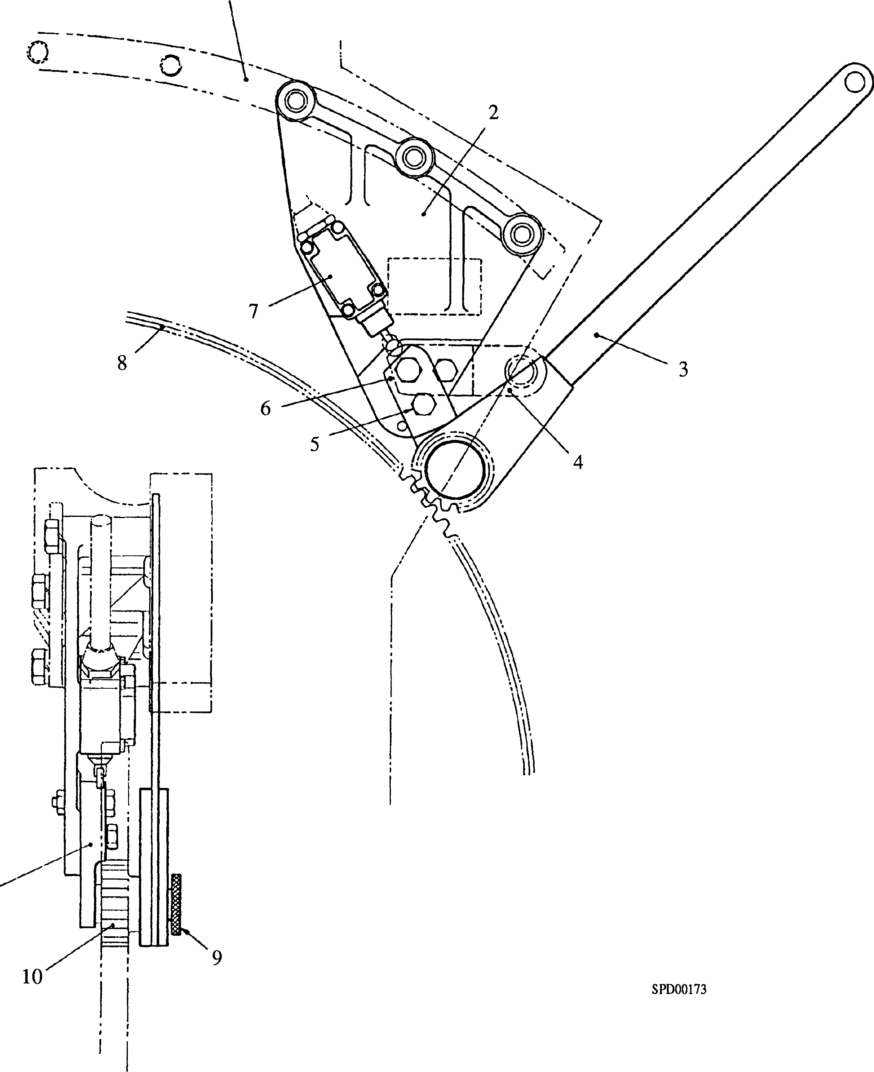

Key To Numbers

1. Pivot arm (engaged)
2. Crankcase
3. Bracket
4. Ratchet spanner
5. Pivot arm
6. Locking screw
7. Limit switch
8. Flywheel
9. Retaining screw
10. Ratchet gear

Fig. DA.l Barring Equipment